Họ Tên: Ao Công Hiếu

MSSV: 21026511

PHẦN I : Các lệnh thao tác với Docker

1. Docker --version

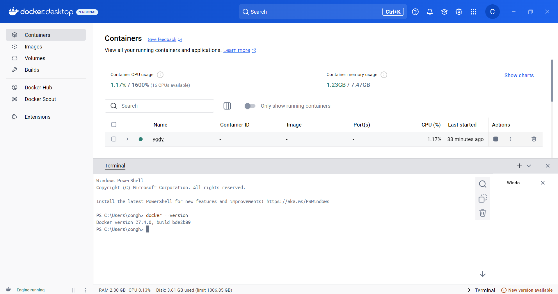

1. Docker run hello-world

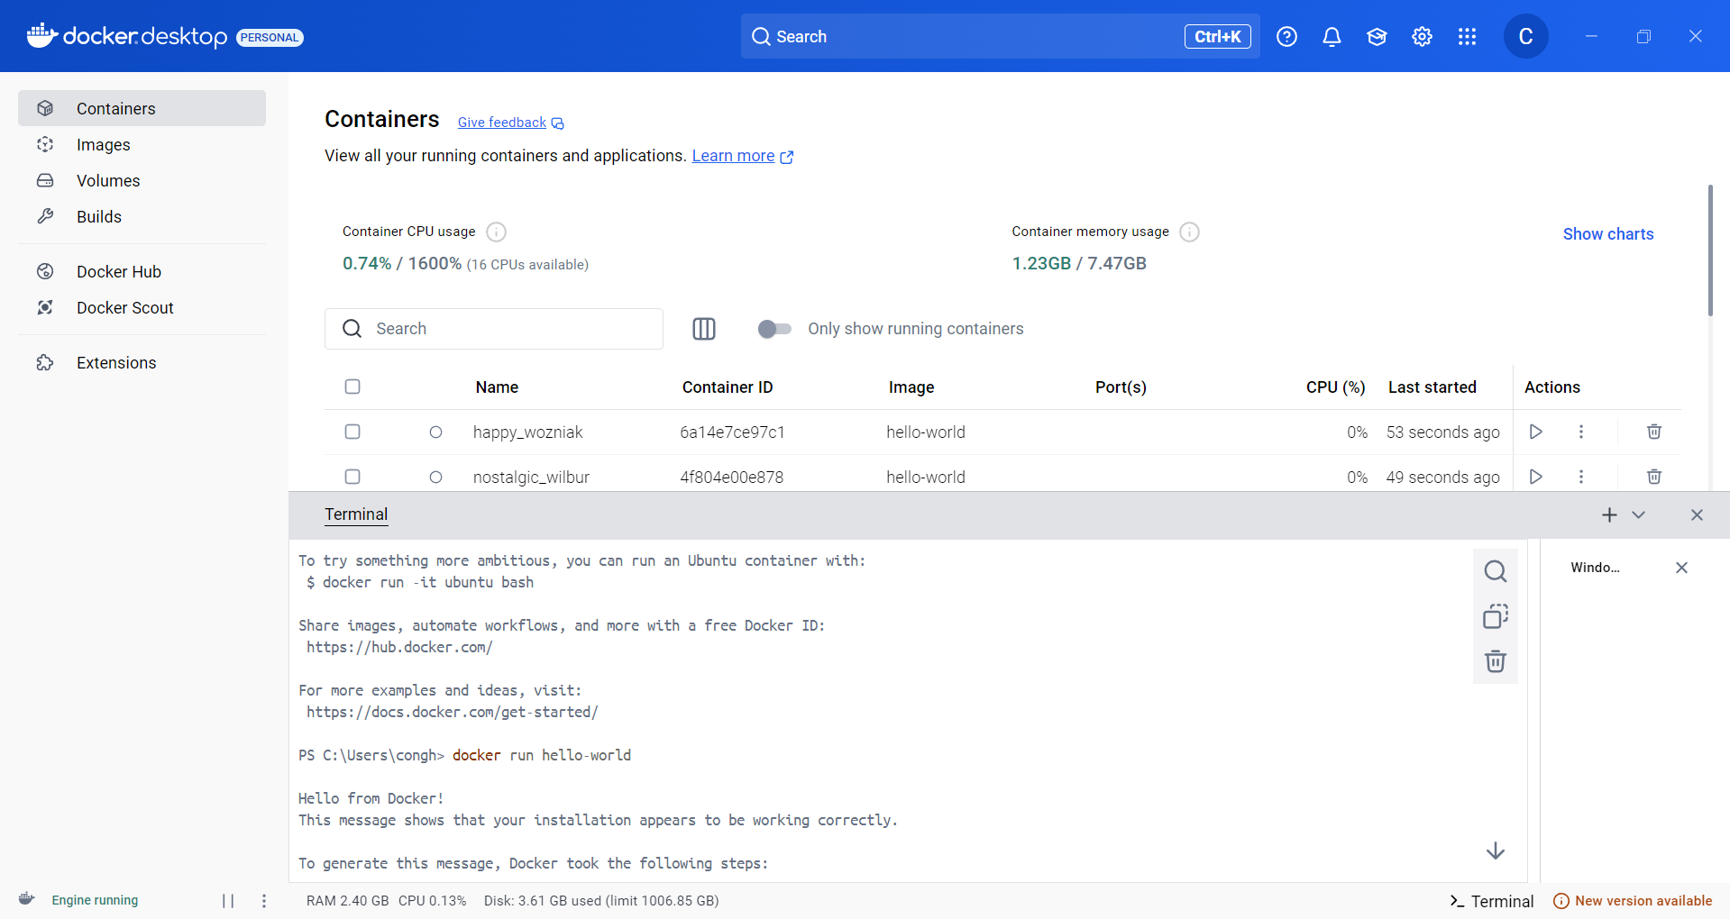

1. Docker pull nginx

1. Docker images

1. Docker -d nginx

1. Docker ps

1. Docker ps -a

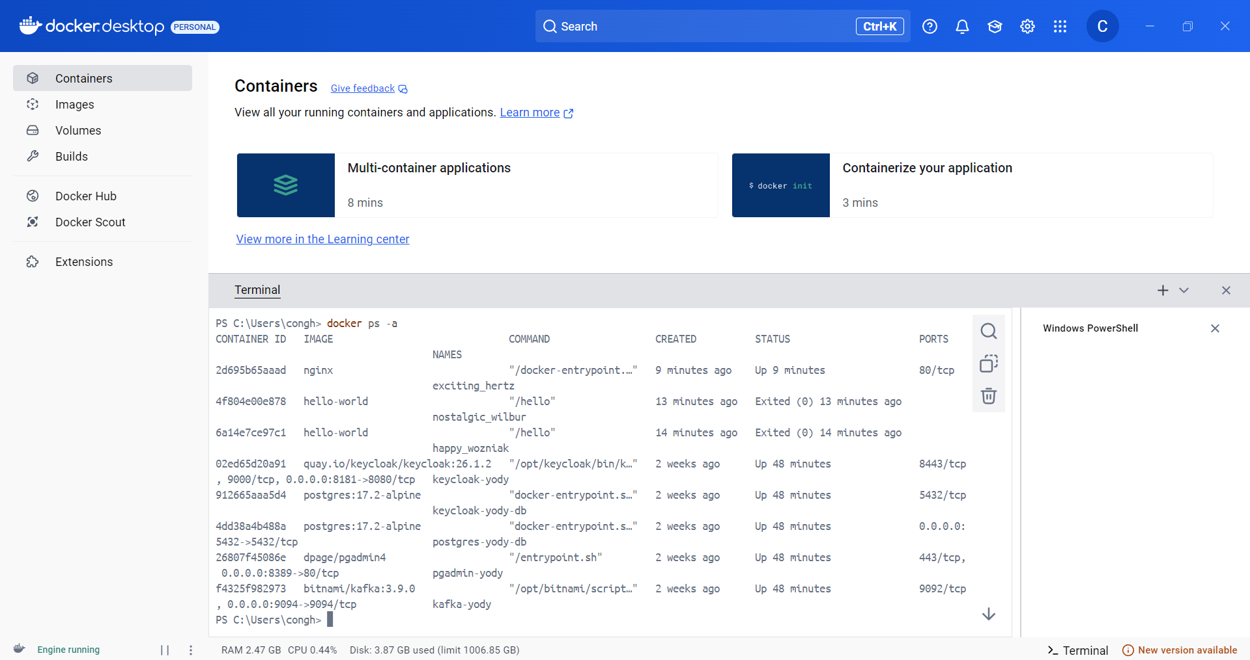

1. Docker logs container_id

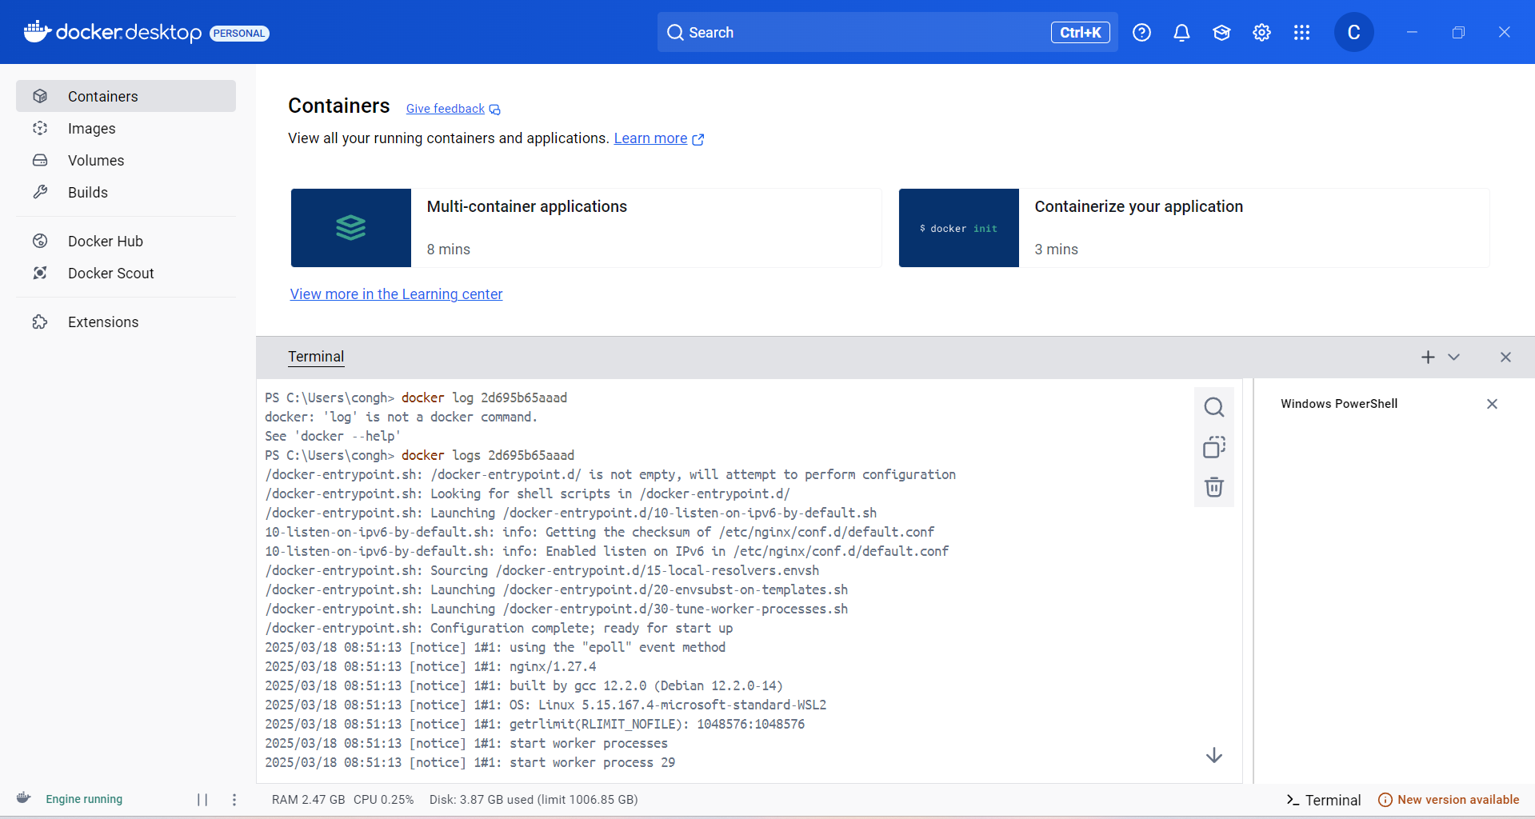

1. Docker exec -it <container_id> /bin/sh

1. Docker stop <container_id>

1. Docker restart<container_id>

1. Docker -rm <container_id>

1. Docker container prune

1. Docker rmi <image_id>

1. Docker image prune -a

1. Docker run -d -p 8080:80 nginx

1. Docker inspect<container_id>

1. Docker run -d -v mydata:/data nginx

1. Docker volume ls

1. Docker volume prune

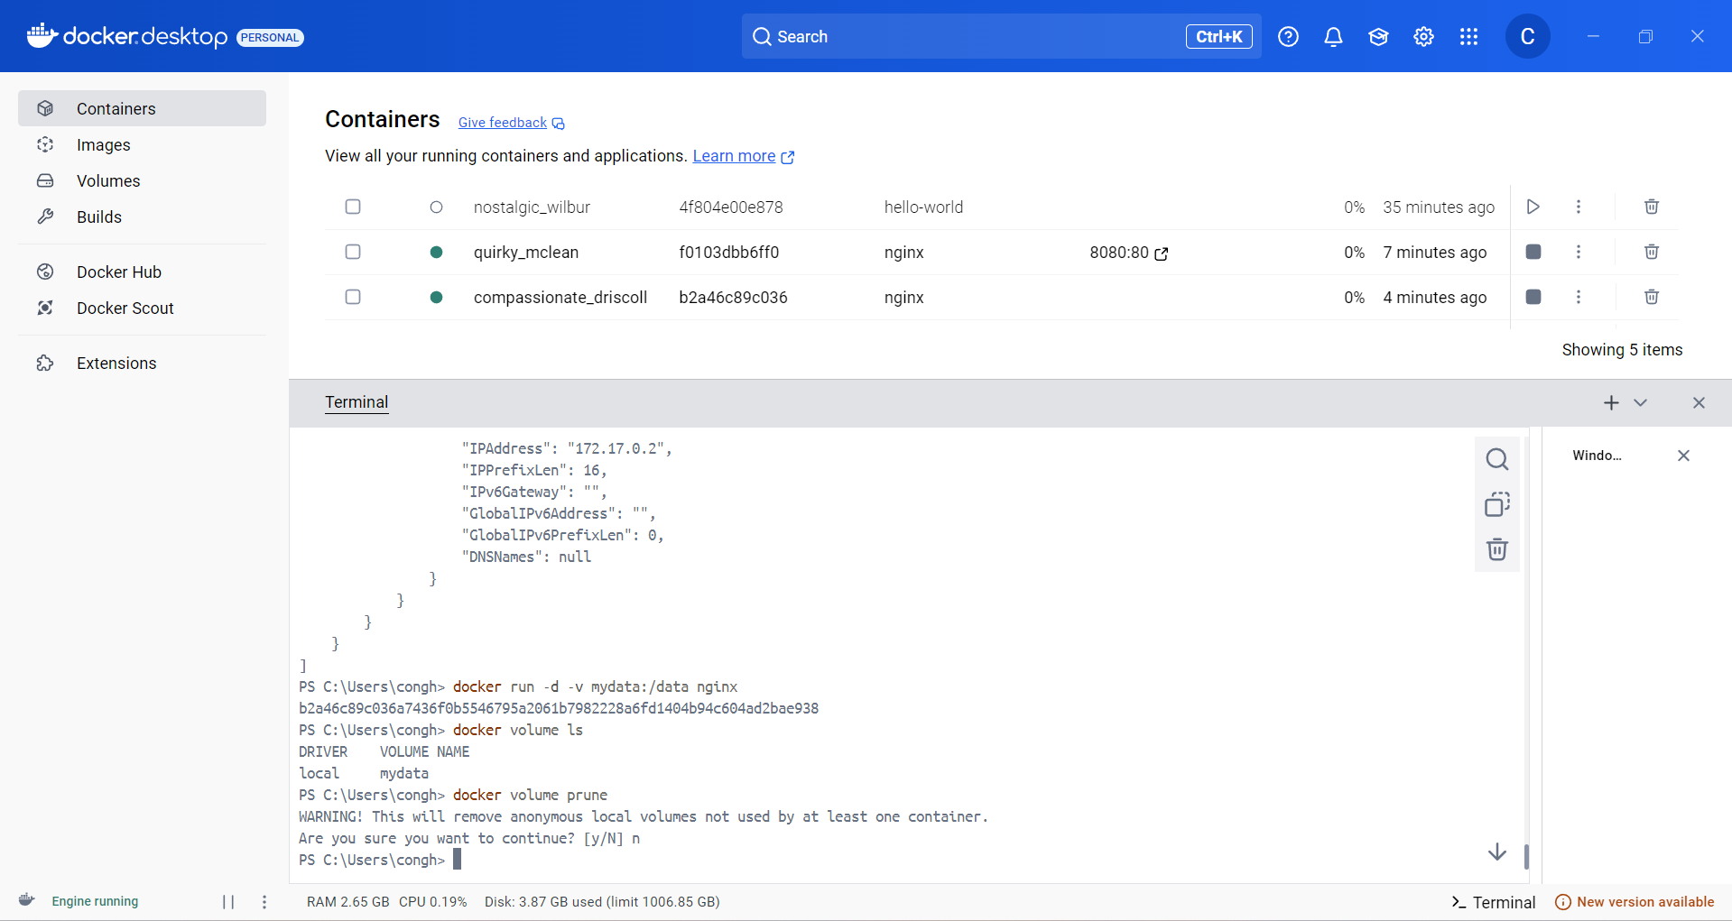

1. Docker run -d –name my_nginx nginx

1. Docker stats

1. Docker network ls

1. Docker network create my_network

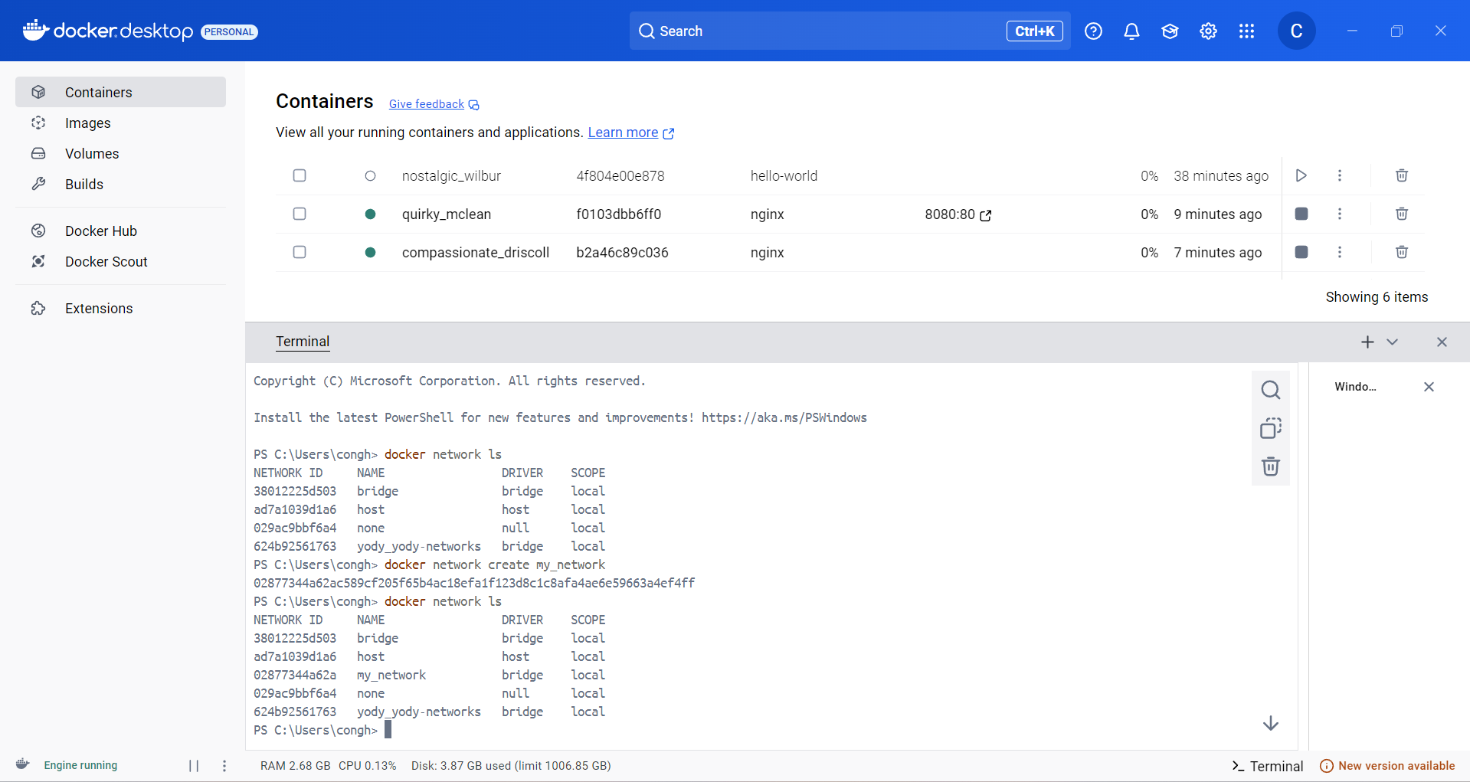

1. Docker run -d –network my_network –name my_container nginx

1. Docker network connect my_network my_nginx

1. Docker run -d -e MY_ENV=hello_world nginx

1. Docker logs -f my_nginx

1. FROM nginx

COPY index.html/urs/share/nginx/html/index.html

1. Docker build -t my_nginx_image

1. Docker run -d -p 8080:80 my_nginx_image

